**Report**

**On**

**Medical Card Generations System**

**By**

**ACKNOWLEDGEMENT**

I have taken efforts in this project. However, it would not have been possible without the kind support and help of my faculty members and friends. I would like to extend my sincere thanks to all of them.

I am highly indebted to (Name of your Mentor) for their guidance and constant supervision as well as for providing necessary information regarding the project & also for their support in completing the project. I am extremely thankful to him for providing such a nice support and guidance, although he had busy schedule managing the corporate affairs.

I would like to express my gratitude towards my parents & member of (College Name) for their kind co-operation and encouragement which help me in completion of this project.

I am thankful to and fortunate enough to get constant encouragement, support and guidance from all Teaching staffs of [Department name] which helped us in successfully completing our project work.

**Abstract**

In every organization there is always need of meeting and conference rooms, to conduct various events.

The aim of this proposed of ‘Medical Card Generations System’ is to improve efficiency, access and accountability of health-care services and also develop to automate its existing manual system by the help of computerized equipment and full-fledge computer software, fulfilling their requirements so that their valuable date can be stored for a longer period with easy accessing and manipulation of the same. Basically the project describes how to handle good performance and provide better services to users. This project can lead to error free, secure, reliable and fast management system. This system will help the organization in better utilization of resources.

**Introduction**

**Introduction:-**

The ‘Medical Card Generations System’ has been designed to override the problem of existing manual system. This web application is supported to eliminate and in some case reduce the hardship faced by manual system. The application is reduced as much as possible to avoid errors while entering the data. It’s also provide message while entering invalid data. No formal knowledge is required for the user to operate this system. Overall we said that ‘Medical Card Generations System’ is user friendly.

In ‘Medical Card Generations System’ we use PHP and MySQL Database. This project keeps the records of medical cards. ‘Medical Card Generations System’ has two module i.e. admin and user.

**Admin Module**

1. **Dashboard**: In this section, admin can briefly view the total medical card created in today’s, yesterday’s and in seven days, total read and unread enquiries.
2. **Medical Card:** In this section, admin can manage medical cards (add/delete/update).
3. **Page:**  In this section, admin can manage about us and contact us pages.
4. **Enquiry:** In this section, admin reads the inquiries which are sent by users.
5. **Search:** In this section, admin can search a particular medical cards by reference number.
6. **Reports of Medical Cards:** In this section admin can view and check medical card details in a particular period.

Admin can also update his profile, change the password and recover the password.

**User Module**

1. **Home Page:**User can visit home page.
2. **Medical Card:**User can view his/her medical card and take print with the help of their Reference Number.
3. **About Us**: User sees the details of .website administrator.
4. **Contact Us**: User can contact with website administrator and sent enquiry to them.

**Note**:  In this project, the MD5 encryption method was used.

**Objective**

Now–a-days, health awareness is not only a growing trend among the nations but also among the individuals. After analyzing and surveying the current health care problems in cities as well as rural areas, we have proposed a “Medical Card Generations System” in order to improve the health care facilities. Then we have focused on analyzing the performance of the proposed health care system to eliminate problems in the existing health care system.

The main objective of the ‘Medical Card Generations System’ project is to manage the details of user medical cards and their enquiries. This ‘Medical Card Generations System’ will definitely reduce the time, energy and money wasted in manually searching the details of the medical cards. With the help of this software, all the services and users can be properly channelized. It is cost effective project and can be used in many organizations.

**Existing System**

The present scenario offers manual data entry. A lot of time is wasted in creating the reports as well as maintaining them. In case, if any query arises to get the information about the booking, queries and registered users, the whole report is re-typed or Xeroxed. This seriously affects the authentication of the system. This Medical Card Generations System is totally outdated and involves high risk of ambiguity and redundancy.

**Proposed System**

Now–a-days, health awareness is not only a growing trend among the nations but also among the individuals. After analyzing and surveying the current health care problems in cities as well as rural areas, we have proposed a “Medical Card Generations System” in order to improve the health care facilities. Then we have focused on analyzing the performance of the proposed health care system to eliminate problems in the existing health care system.

The proposed “Medical Card Generations System” is to have everything completely automated and computerized. The software is very easy to use and manage even for a non technical person. The redundancy and ambiguity will be removed by assigning reference number to each medical card.

**Requirement Specification**

**Hardware Configuration:**

**Client Side:**

|  |  |
| --- | --- |
| **RAM RAMfgdfRA RAM** | 512 MB |
|  |  |
| **Hard disk** | 10 GB |
|  |  |
| **Processor** | 1.0 GHz |
|  |  |

**Server side:**

|  |  |
| --- | --- |
| **RAM** | **1 GB** |
| **Hard disk** | **20 GB** |
| **Processor** | **2.0 GHz** |

**Software Requirement:**

**Client Side:**

|  |  |
| --- | --- |
| **Web Browser** | Google Chrome or any compatible browser |
| **Operating System** | Windows or any equivalent OS |

**Server Side:**

|  |  |
| --- | --- |
| **Web Server** | APACHE |
| **Server side Language** | PHP5.6 or above version |
| **Database Server** | MYSQL |
| **Web Browser** | Google Chrome or any compatible browser |
| **Operating System** | Windows or any equivalent OS |

**APACHE**

The Apache HTTP Server Project is an effort to develop and maintain an open-source HTTP server for modern operating systems including UNIX and Windows. The goal of this project is to provide a secure, efficient and extensible server that provides HTTP services in sync with the current HTTP standards.

The Apache HTTP Server ("httpd") was launched in 1995 and it has been the most popular web server on the Internet since April 1996. It has celebrated its 20th birthday as a project in February 2015.

**PHP**

* PHP stands for PHP: Hypertext Preprocessor.
* PHP is a server-side scripting language, like ASP.
* PHP scripts are executed on the server.
* PHP supports many databases (MYSQL, Informix, Oracle, Sybase, Solid, Generic ODBC, etc.).
* PHP is an open source software .
* PHP is free to download and use.

**MYSQL**

* MYSQL is a database server
* MYSQL is ideal for both small and large applications
* MYSQL supports standard SQL
* MYSQL compiles on a number of platforms
* MYSQL is free to download and use

How to access MySQL: <http://localhost/phpmyadmin>

**Analysis and Design**

**Analysis:**

The present scenario offers manual data entry.  A lot of time is wasted in creating the reports as well as maintaining them. In case, if any query arises to get the information about the client, the whole report is re-typed or Xeroxed. This seriously affects the authentication of the system. This Client Management System is totally outdated and involves high risk of ambiguity and redundancy.

**Disadvantage of present system:**

* **Not user friendly:** The present system not user friendly because data is not stored in structure and proper format.
* **Manual Control:** All report calculation is done manually so there is a chance of error.
* **Lots of paper work:** Visitors maintain in the register so lots of paper require storing details.
* **Time consuming**

**Design Introduction:**

Design is the first step in the development phase for any techniques and principles for the purpose of defining a device, a process or system in sufficient detail to permit its physical realization.

Once the software requirements have been analyzed and specified the software design involves three technical activities - design, coding, implementation and testing that are required to build and verify the software.

The design activities are of main importance in this phase, because in this activity, decisions ultimately affecting the success of the software implementation and its ease of maintenance are made. These decisions have the final bearing upon reliability and maintainability of the system. Design is the only way to accurately translate the customer’s requirements into finished software or a system.

Design is the place where quality is fostered in development. Software design is a process through which requirements are translated into a representation of software. Software design is conducted in two steps. Preliminary design is concerned with the transformation of requirements into data

UML Diagrams:

Actor:  
 A coherent set of roles that users of use cases play when interacting with the use `cases.

Use case: A description of sequence of actions, including variants, that a system performs that yields an observable result of value of an actor.

UML stands for Unified Modeling Language. UML is a language for specifying, visualizing and documenting the system. This is the step while developing any product after analysis. The goal from this is to produce a model of the entities involved in the project which later need to be built. The representation of the entities that are to be used in the product being developed need to be designed.

**USECASE DIAGRAMS:**

Use case diagrams model behavior within a system and helps the developers understand of what the user require. The stick man represents what’s called an actor.

Use case diagram can be useful for getting an overall view of the system and clarifying who can do and more importantly what they can’t do.

Use case diagram consists of use cases and actors and shows the interaction between the use case and actors.

* The purpose is to show the interactions between the use case and actor.
* To represent the system requirements from user’s perspective.
* An actor could be the end-user of the system or an external system.

**USECASE DIAGRAM:** A Use case is a description of set of sequence of actions. Graphically it is rendered as an ellipse with solid line including only its name. Use case diagram is a behavioral diagram that shows a set of use cases and actors and their relationship. It is an association between the use cases and actors. An actor represents a real-world object. Primary Actor – Sender, Secondary Actor Receiver.

**Use Case Diagrams:**

**Admin**

**Users**

**Class Diagram:**

A description of set of objects that share the same attributes operations, relationships, and semantics.

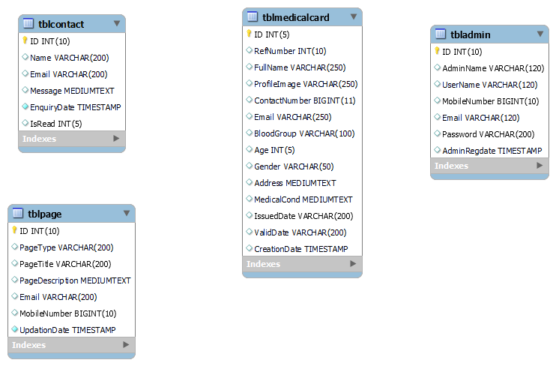

**ER Diagram:**

The Entity-Relationship (ER) model was originally proposed by Peter in 1976 [Chen76] as a way to unify the network and relational database views. Simply stated the ER model is a conceptual data model that views the real world as entities and relationships. A basic component of the model is the Entity-Relationship diagram which is used to visually represent data objects. Since Chen wrote his paper the model has been extended and today it is commonly used for database design for the database designer, the utility of the ER model is:

* It maps well to the relational model. The constructs used in the ER model can easily be transformed into relational tables.
* It is simple and easy to understand with a minimum of training. Therefore, the model can be used by the database designer to communicate the design to the end user.
* In addition, the model can be used as a design plan by the database developer to implement a data model in specific database management software.

**ER Notation**

There is no standard for representing data objects in ER diagrams. Each modeling methodology uses its own notation. The original notation used by Chen is widely used in academics texts and journals but rarely seen in either CASE tools or publications by non-academics. Today, there are a number of notations used; among the more common are Bachman, crow's foot, and IDEFIX.

All notational styles represent entities as rectangular boxes and relationships as lines connecting boxes. Each style uses a special set of symbols to represent the cardinality of a connection. The notation used in this document is from Martin. The symbols used for the basic ER constructs are:

* **Entities** are represented by labeled rectangles. The label is the name of the entity. Entity names should be singular nouns.
* **Relationships** are represented by a solid line connecting two entities. The name of the relationship is written above the line. Relationship names should be verbs
* **Attributes**, when included, are listed inside the entity rectangle. Attributes which are identifiers are underlined. Attribute names should be singular nouns.
* **Cardinality** of many is represented by a line ending in a crow's foot. If the crow's foot is omitted, the cardinality is one.

**Existence** is represented by placing a circle or a perpendicular bar on the line. Mandatory existence is shown by the bar (looks like a 1) next to the entity for an instance is required. Optional existence is shown by placing a circle next to the entity that is optional.

**ER Diagram**

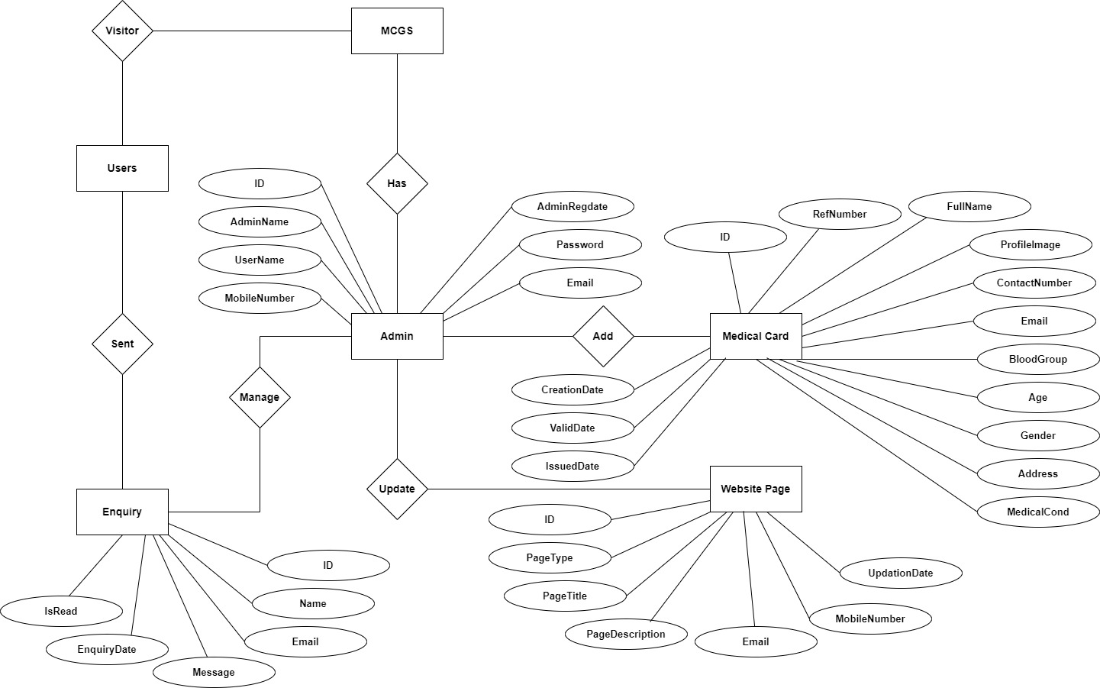

**Data Flow Diagram**

# Data Flow Diagrams

A Data Flow Diagram (DFD) is a traditional visual representation of the information flows within a system. A neat and clear DFD can depict the right amount of the system requirement graphically. It can be manual, automated, or a combination of both.

It shows how data enters and leaves the system, what changes the information, and where data is stored.

The objective of a DFD is to show the scope and boundaries of a system as a whole. It may be used as a communication tool between a system analyst and any person who plays a part in the order that acts as a starting point for redesigning a system. The DFD is also called as a data flow graph or bubble chart.

**The following observations about DFDs are essential:**

1. All names should be unique. This makes it easier to refer to elements in the DFD.
2. Remember that DFD is not a flow chart. Arrows is a flow chart that represents the order of events; arrows in DFD represents flowing data. A DFD does not involve any order of events.
3. Suppress logical decisions. If we ever have the urge to draw a diamond-shaped box in a DFD, suppress that urge! A diamond-shaped box is used in flow charts to represents decision points with multiple exists paths of which the only one is taken. This implies an ordering of events, which makes no sense in a DFD.
4. Do not become bogged down with details. Defer error conditions and error handling until the end of the analysis.

Standard symbols for DFDs are derived from the electric circuit diagram analysis and are shown in fig:

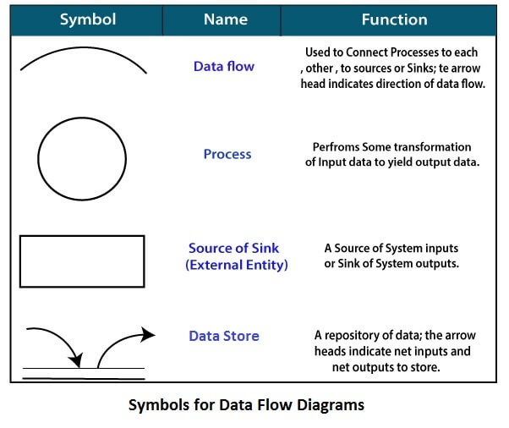

**Circle:** A circle (bubble) shows a process that transforms data inputs into data outputs.

**Data Flow:** A curved line shows the flow of data into or out of a process or data store.

**Data Store:** A set of parallel lines shows a place for the collection of data items. A data store indicates that the data is stored which can be used at a later stage or by the other processes in a different order. The data store can have an element or group of elements.

**Source or Sink:** Source or Sink is an external entity and acts as a source of system inputs or sink of system outputs.

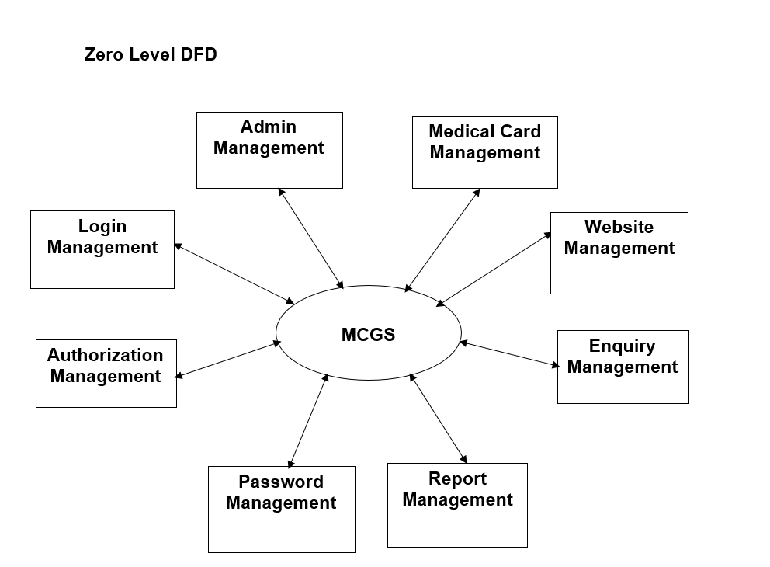

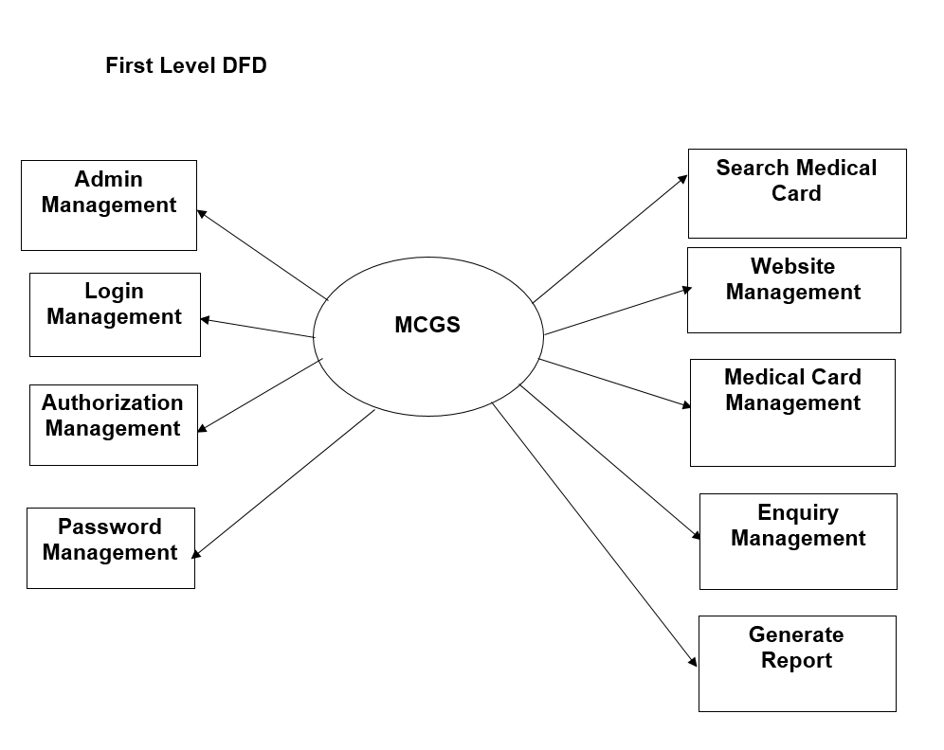

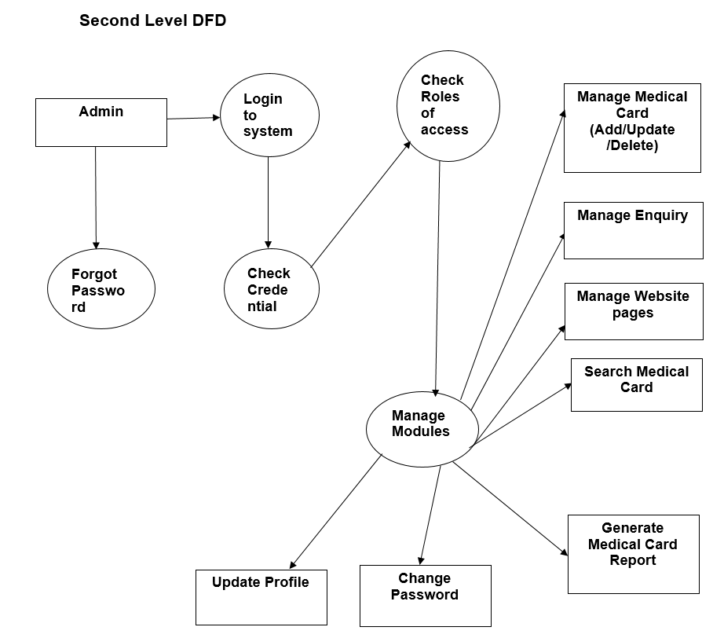

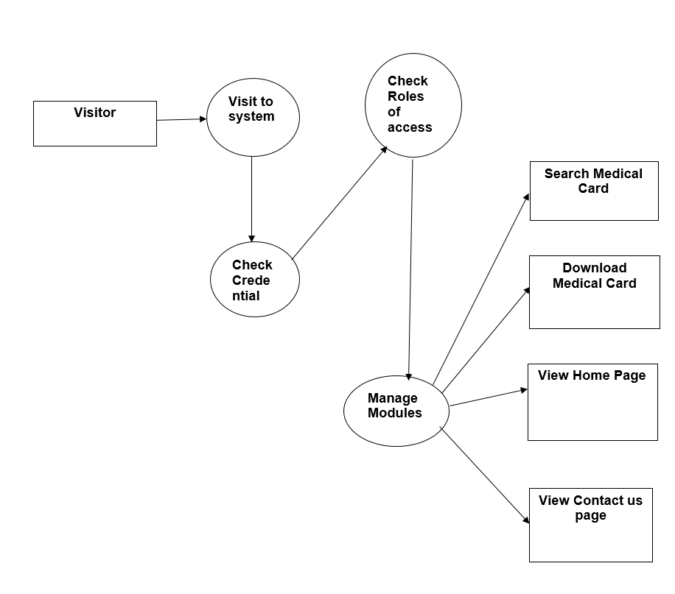

**MySQL Data Tables:**

**Admin Table :**( Table name is admin)

This store admin personal and login details.

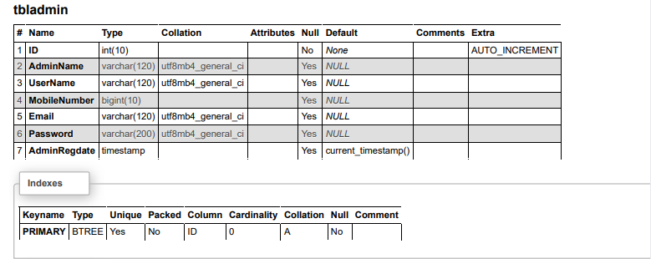

**Contact Table (**Table name is tblcontact)

This store the detail of enquiries which is sent by users.

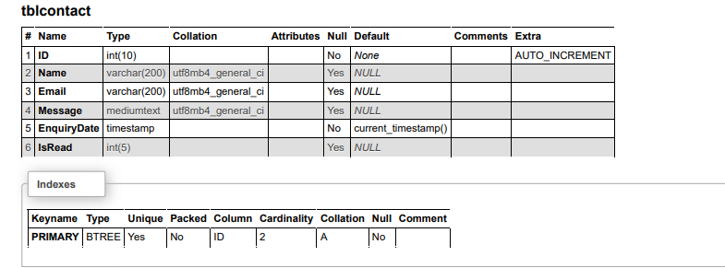

**Page Table:** (Table name is tblpage)

This table stores the about us and contact us details.

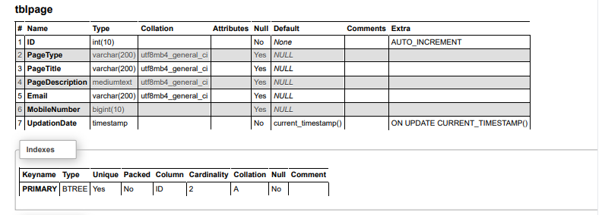

**Medical Card Table:** (Table name is tblmedicalcard)

This table stores the details of users medical card.

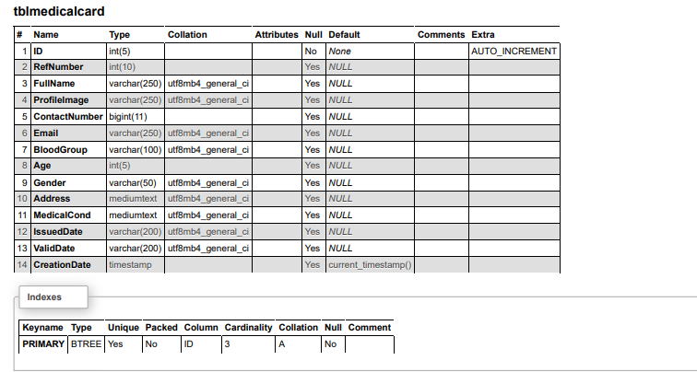

**Schema Diagram**

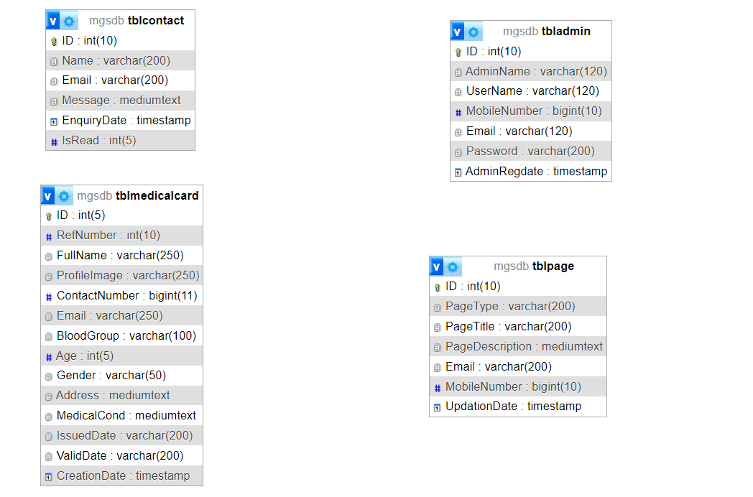

**Implementation and System Testing**

After all phase have been perfectly done, the system will be implemented to the server and the system can be used.

**System Testing**

The goal of the system testing process was to determine all faults in our project .The program was subjected to a set of test inputs and many explanations were made and based on these explanations it will be decided whether the program behaves as expected or not. Our Project went through two levels of testing

1. Unit testing

2. Integration testing

**UNIT TESTING**

Unit testing is commenced when a unit has been created and effectively reviewed .In order to test a single module we need to provide a complete environment i.e. besides the section we would require

* The procedures belonging to other units that the unit under test calls
* Non local data structures that module accesses
* A procedure to call the functions of the unit under test with appropriate parameters

**1. Test for the admin module**

* **Testing admin login form-**This form is used for log in of administrator of the system. In this form we enter the username and password if both are correct administration page will open otherwise if any of data is wrong it will get redirected back to the login page and again ask the details
* **Report Generation:** admin can generate report from the main database.

**INTEGRATION TESTING**

In the Integration testing we test various combination of the project module by providing the input.

The primary objective is to test the module interfaces in order to confirm that no errors are occurring when one module invokes the other module.

**Evaluation**

**Project URL:** [**http://localhost/**](http://localhost/hbms)**mcgs**

**Home Page**

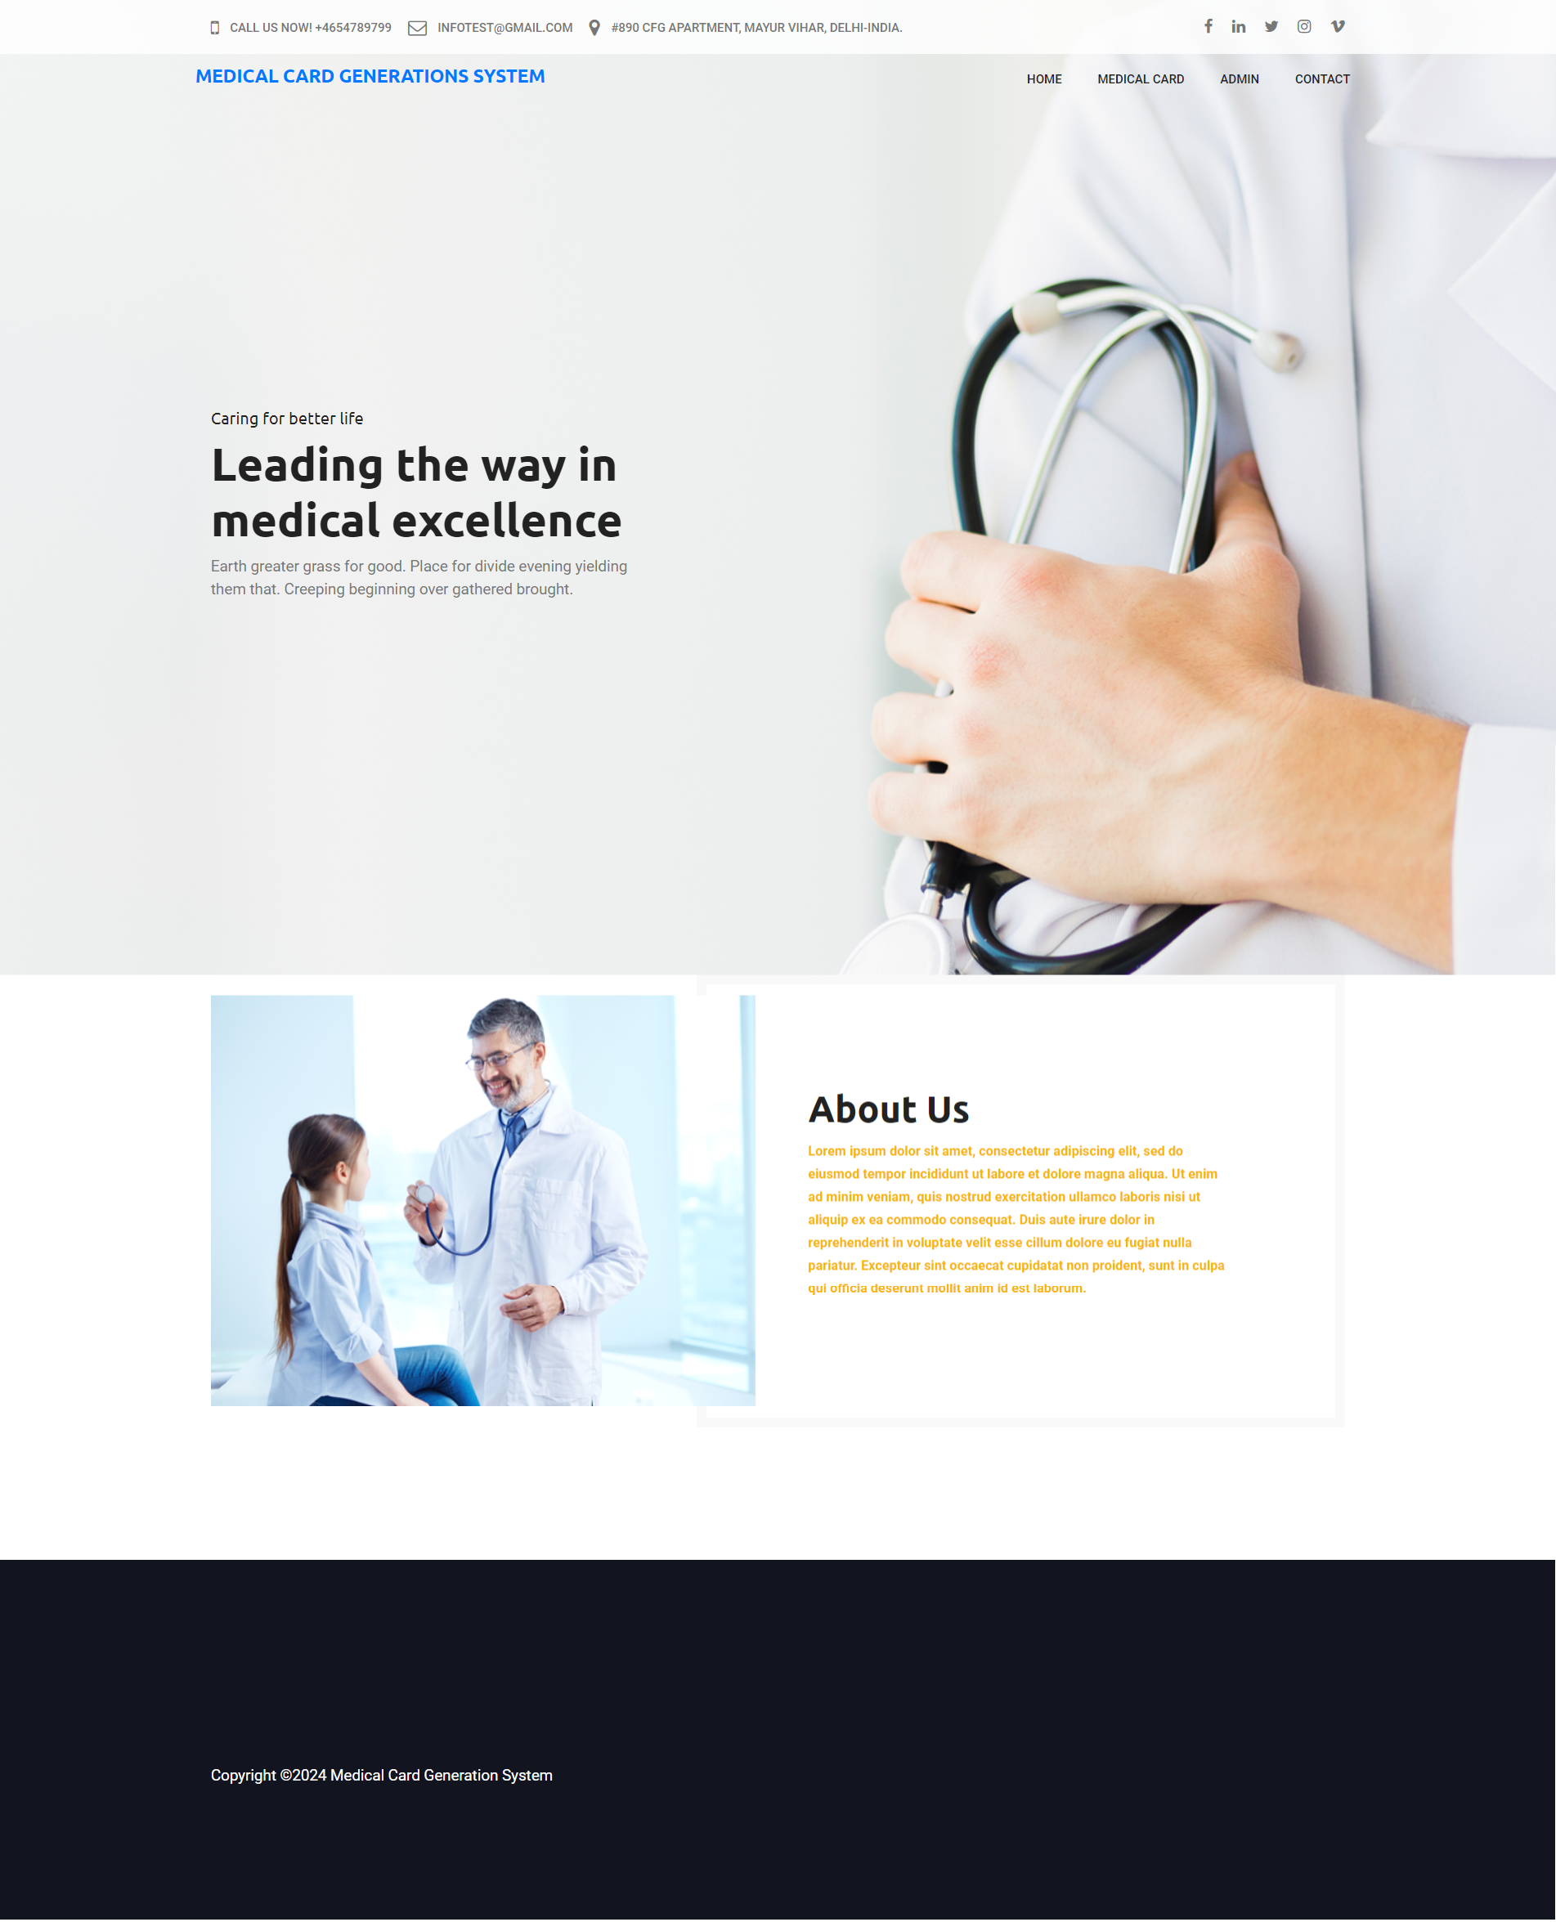

**View Medical Card Details**

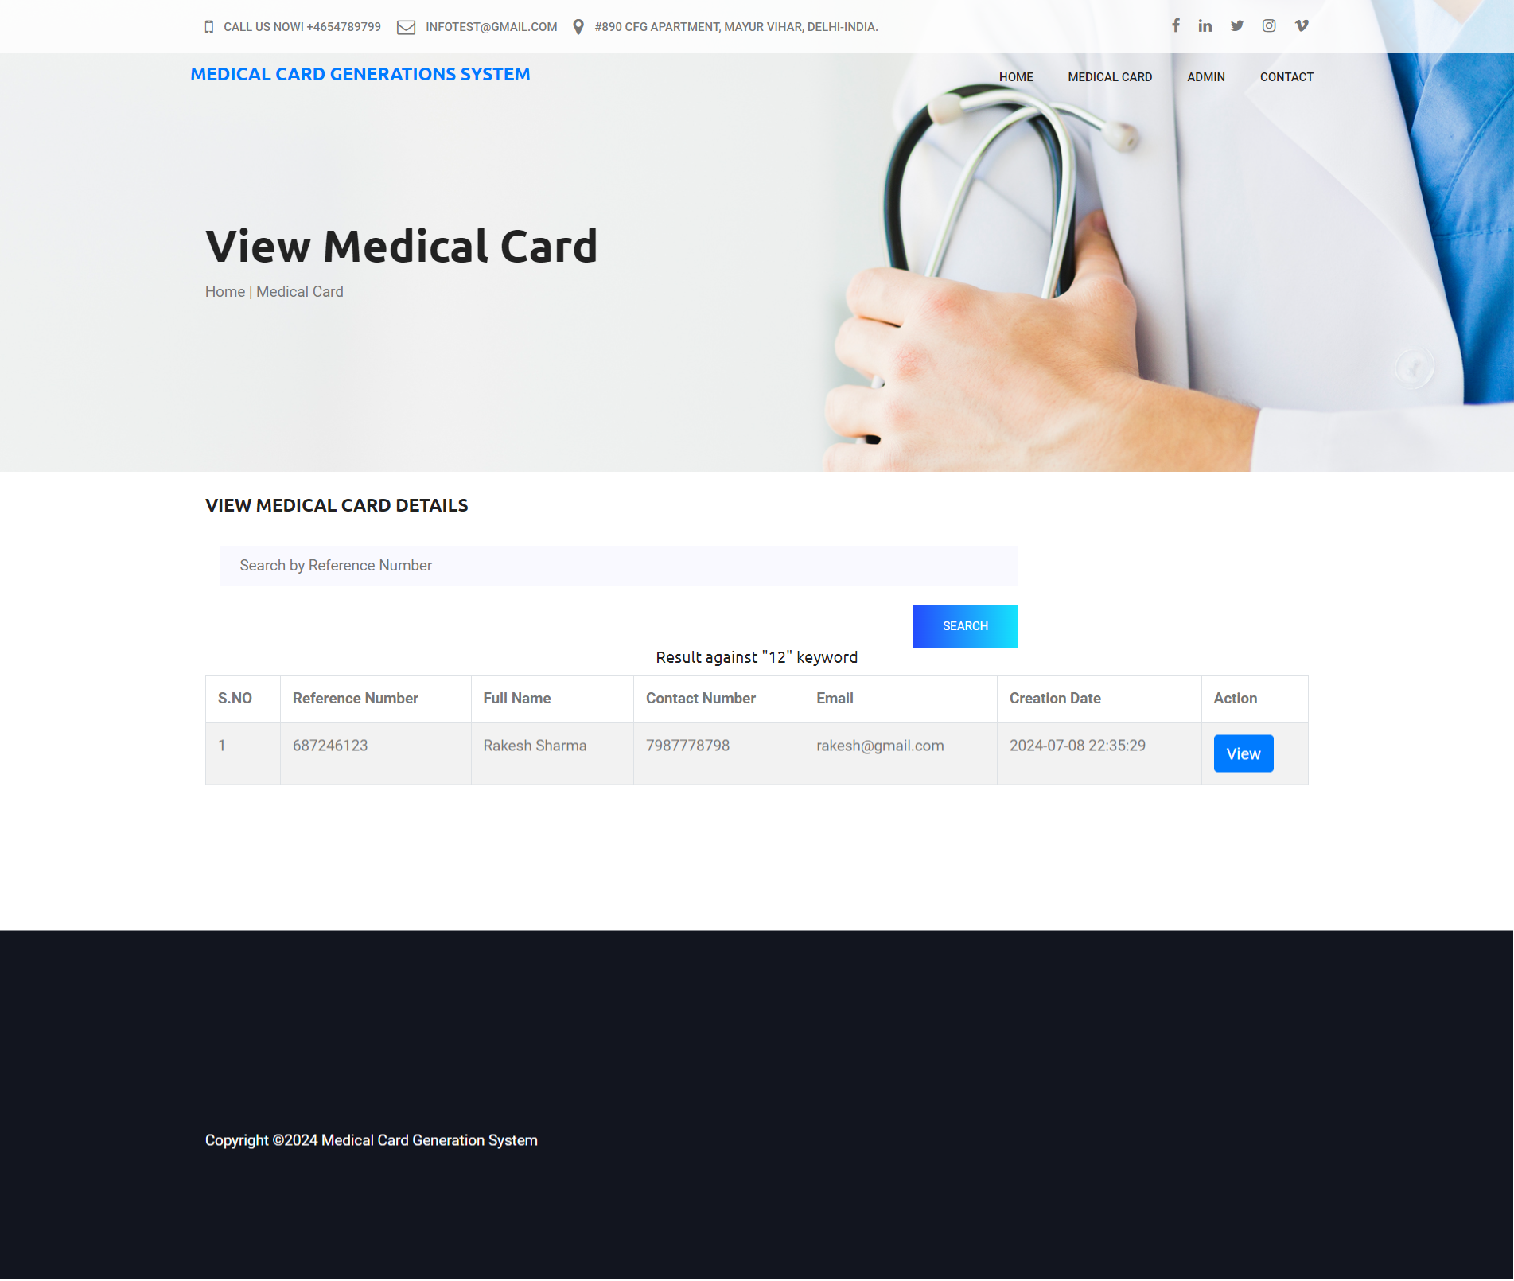

**Print Medical Card**

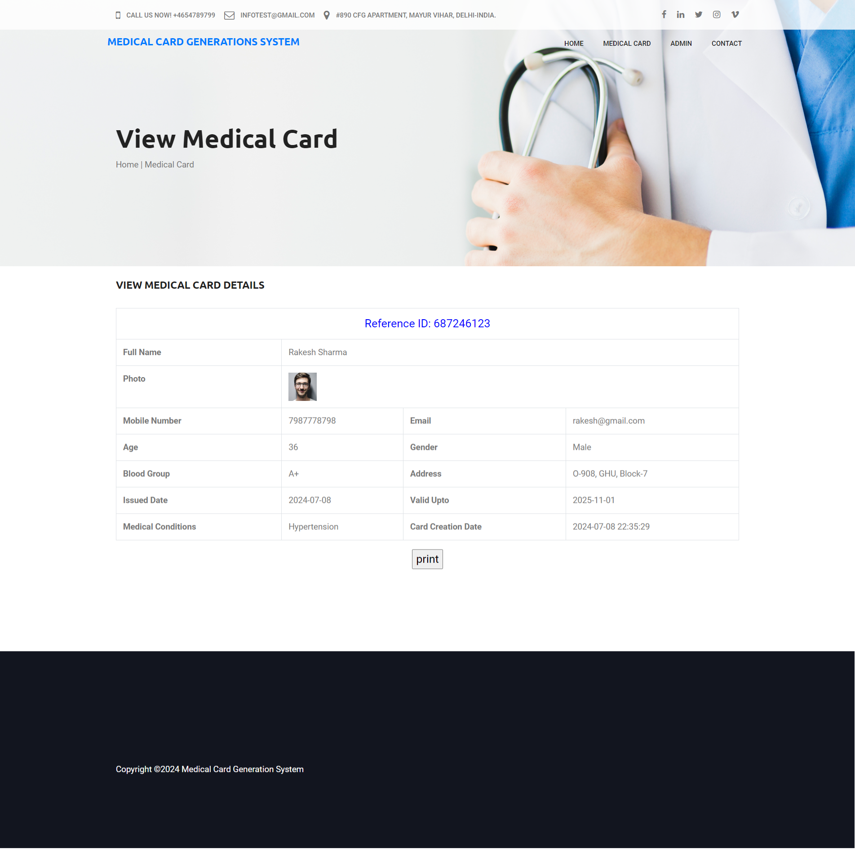

**Contact Us Page**

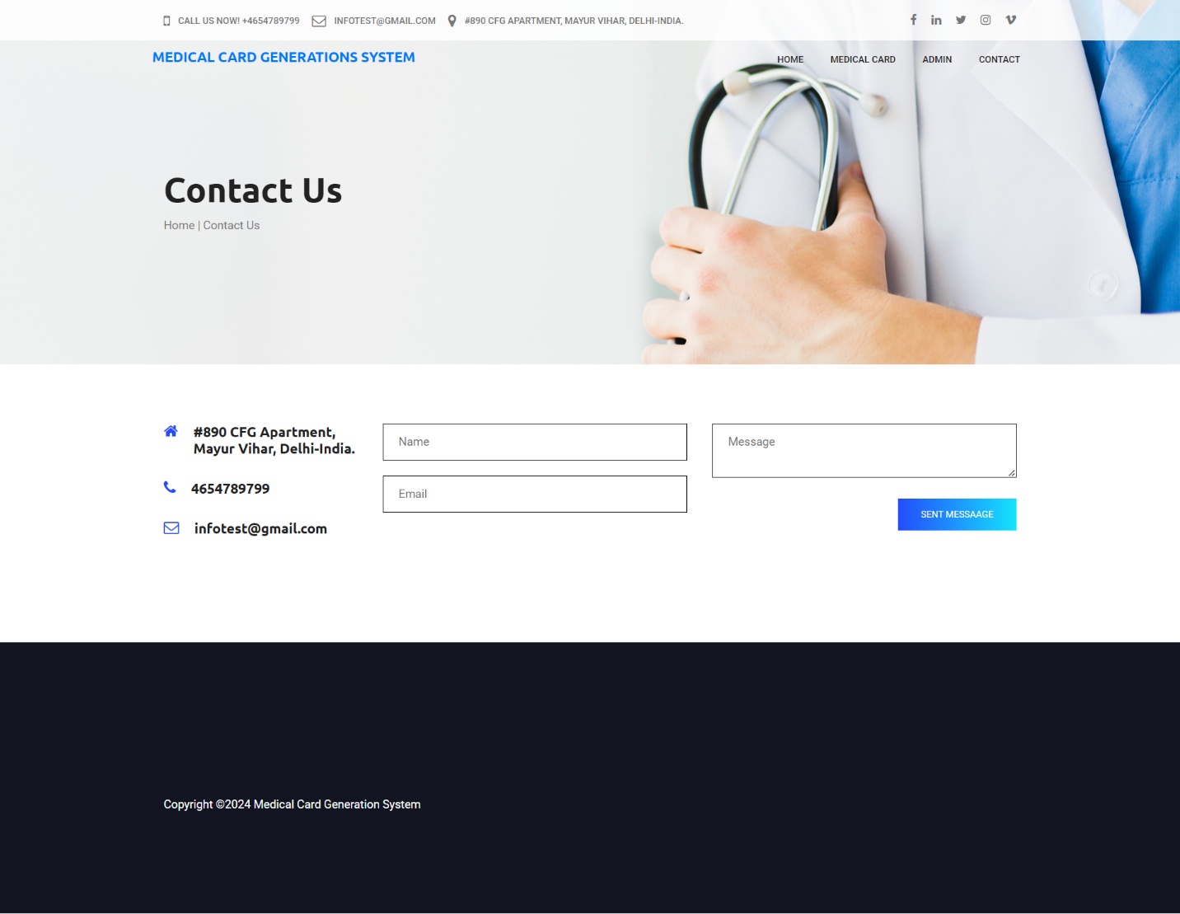

**Admin Panel**

**Login Page**

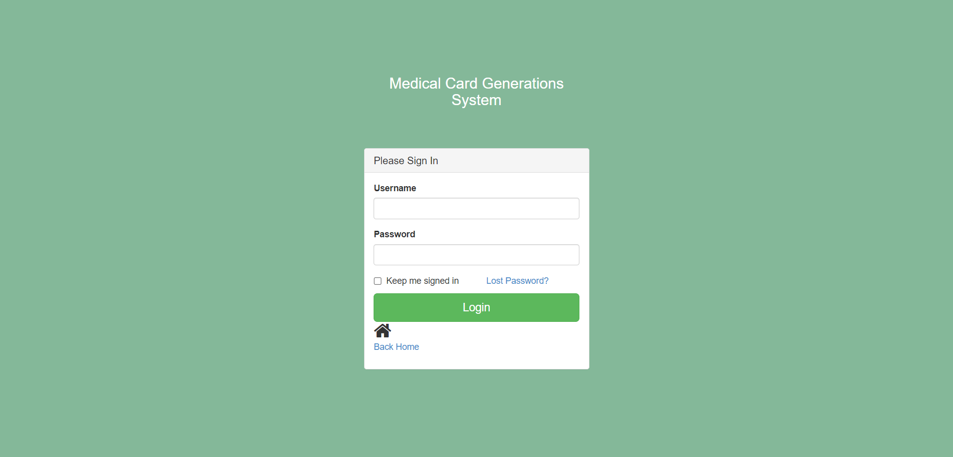

**Forgot Password Page**

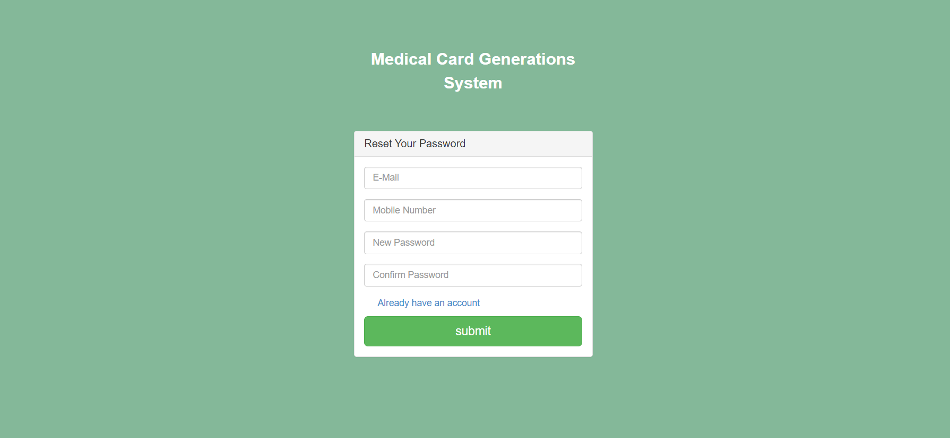

**Dashboard**

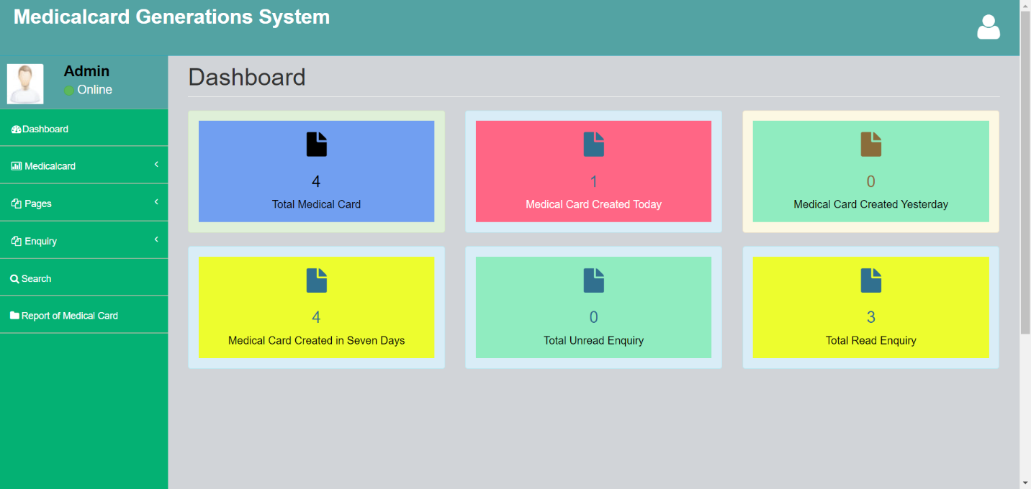

**Profile**

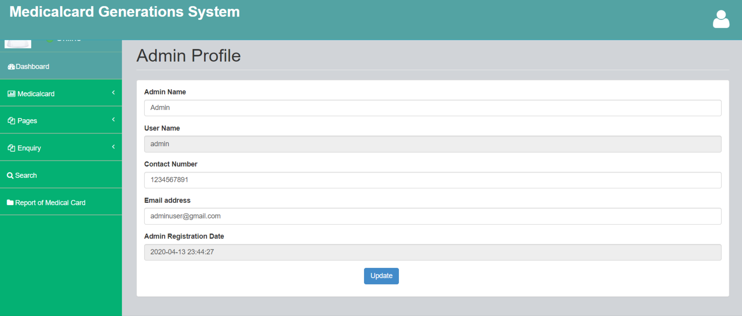

**Change Password**

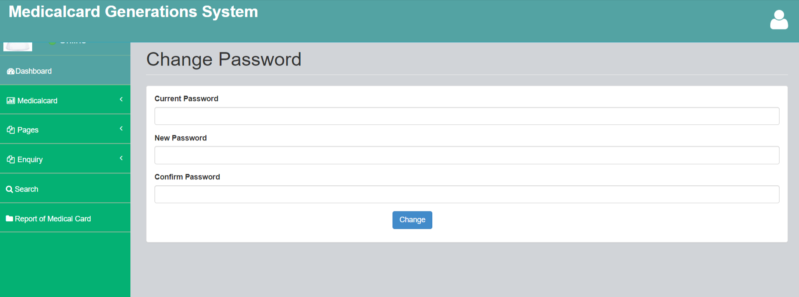

**Add Medical Card**

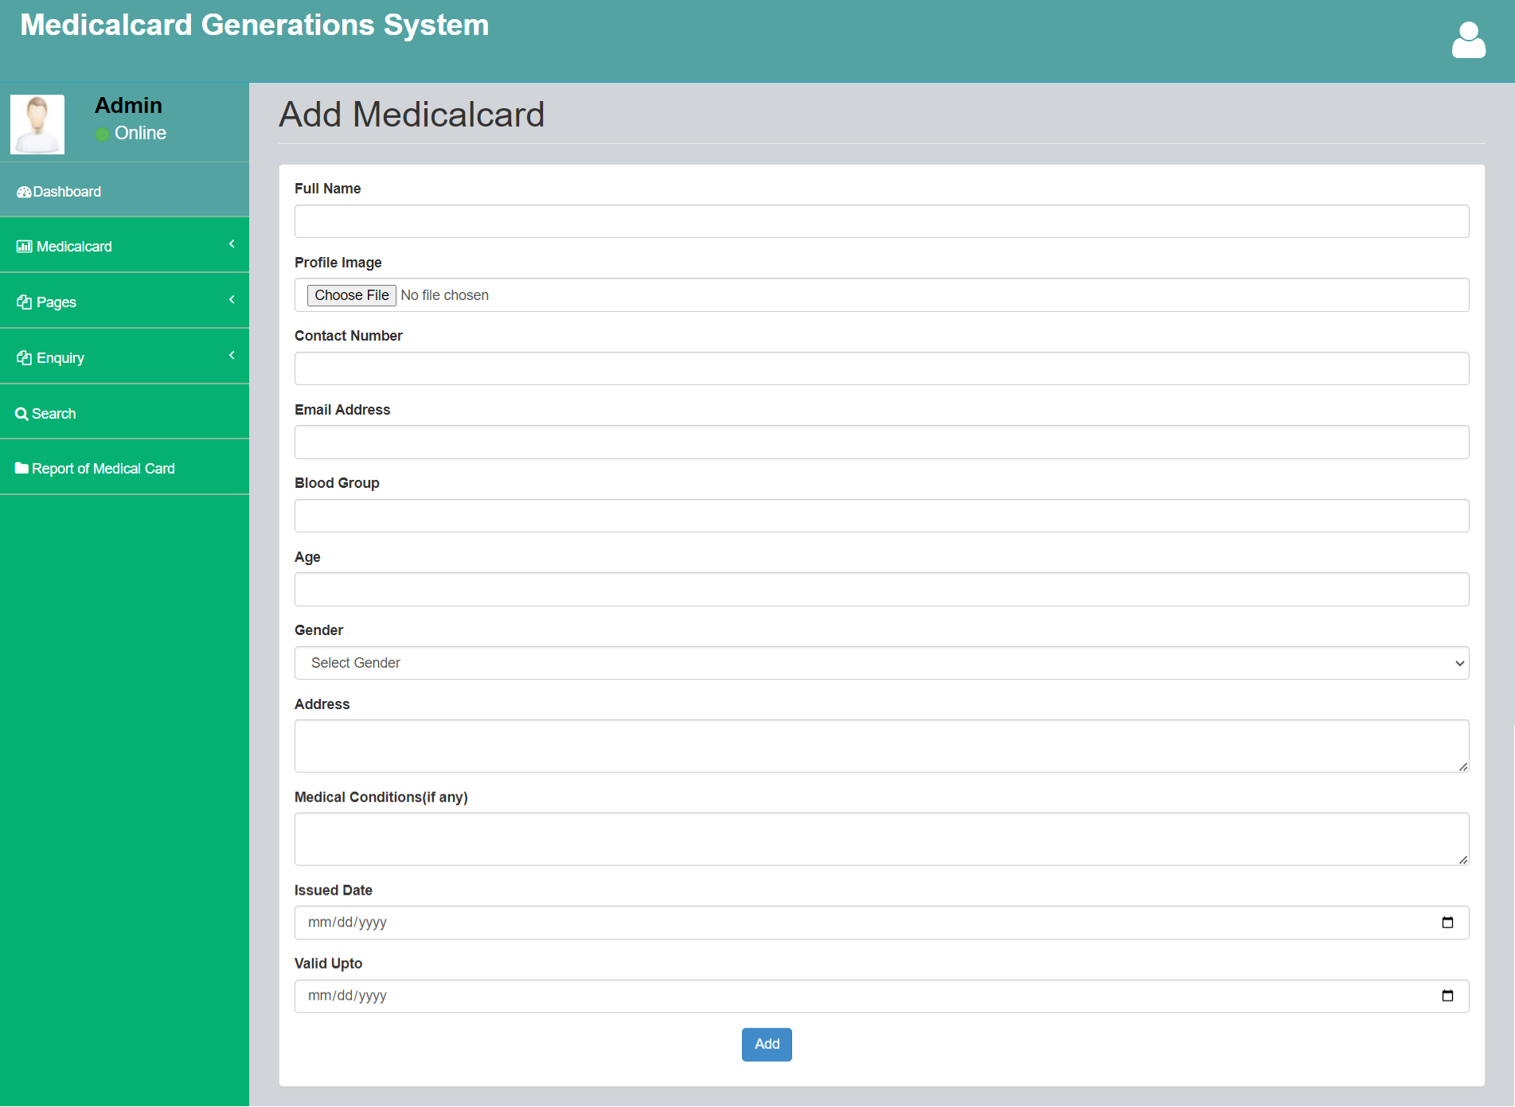

**Manage Medical Card**

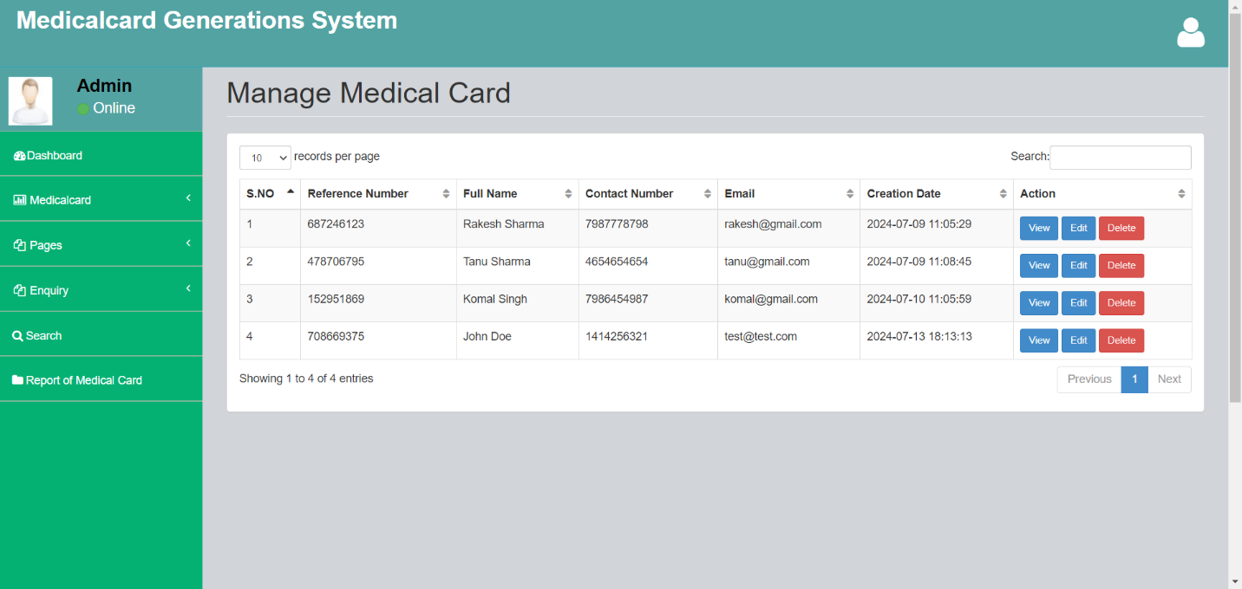

**Update Medical Card**

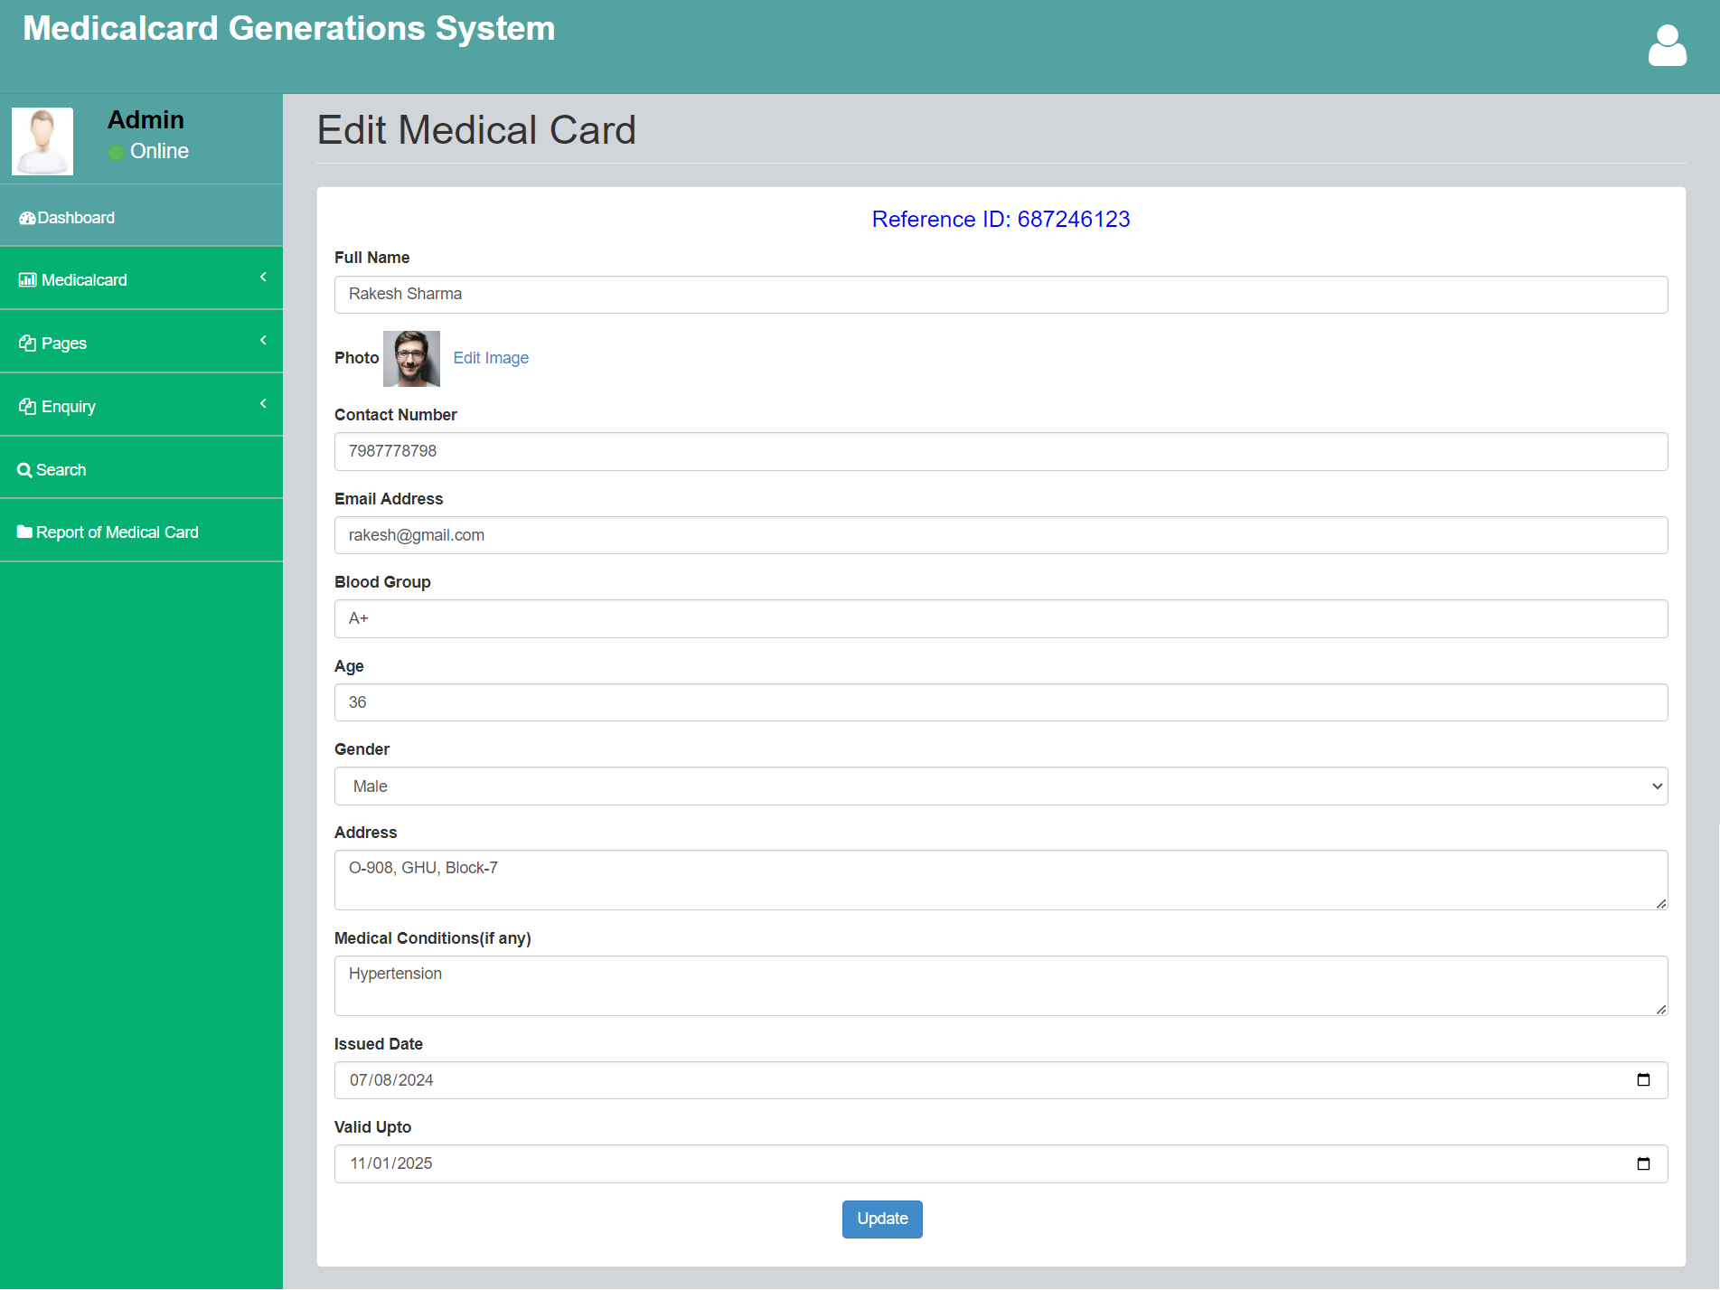

**Update Image**

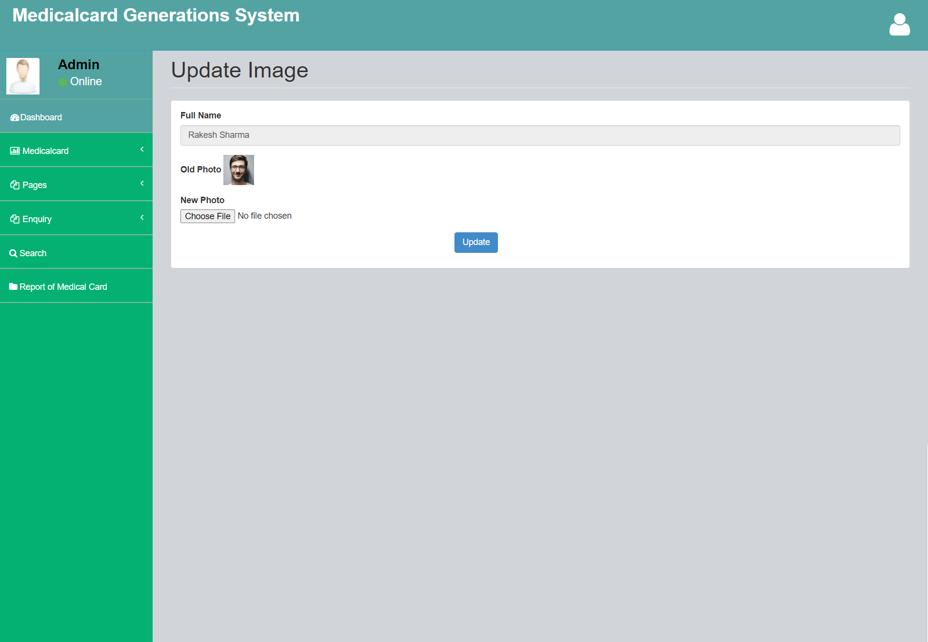

**Print Medical Card**

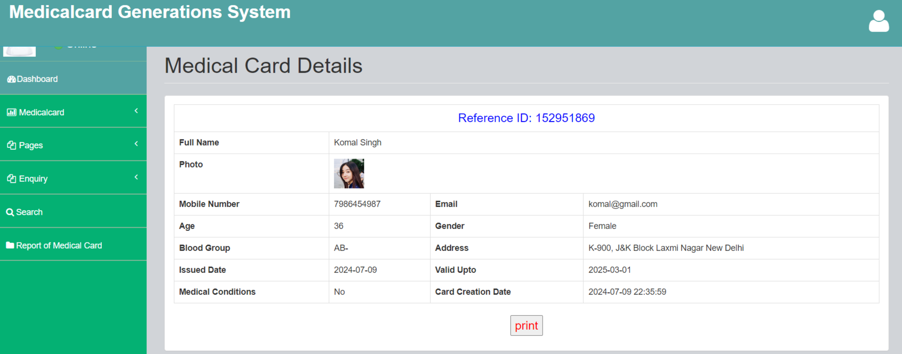

**About Us Page**

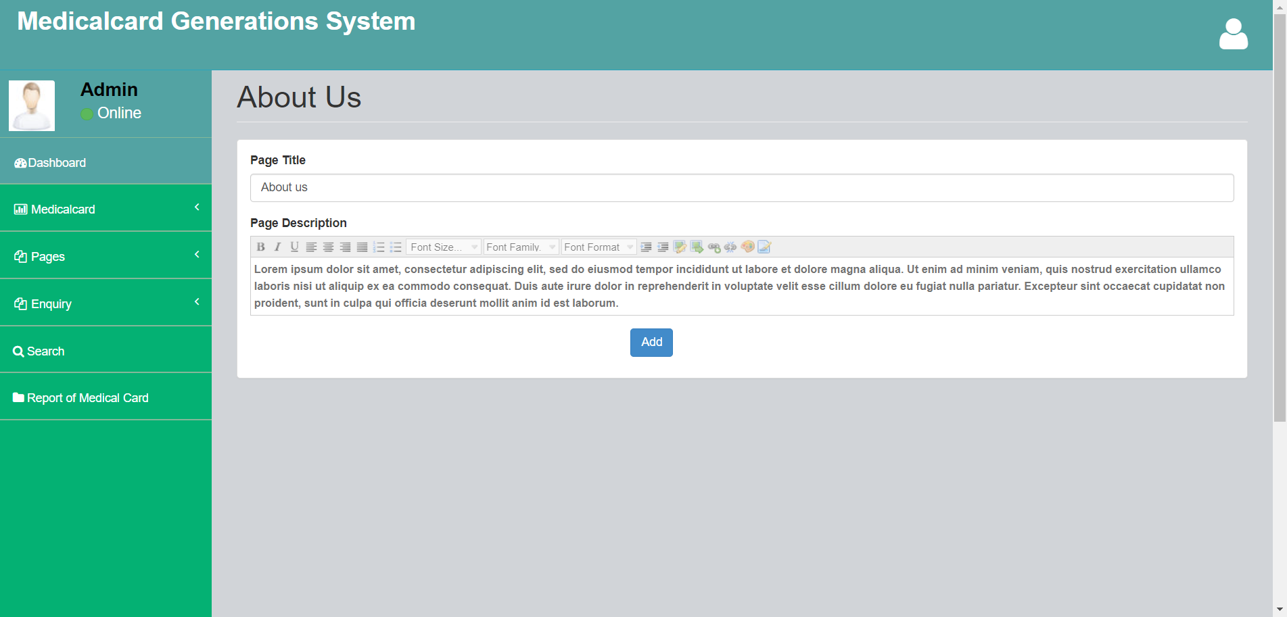

**Contact Us Page**

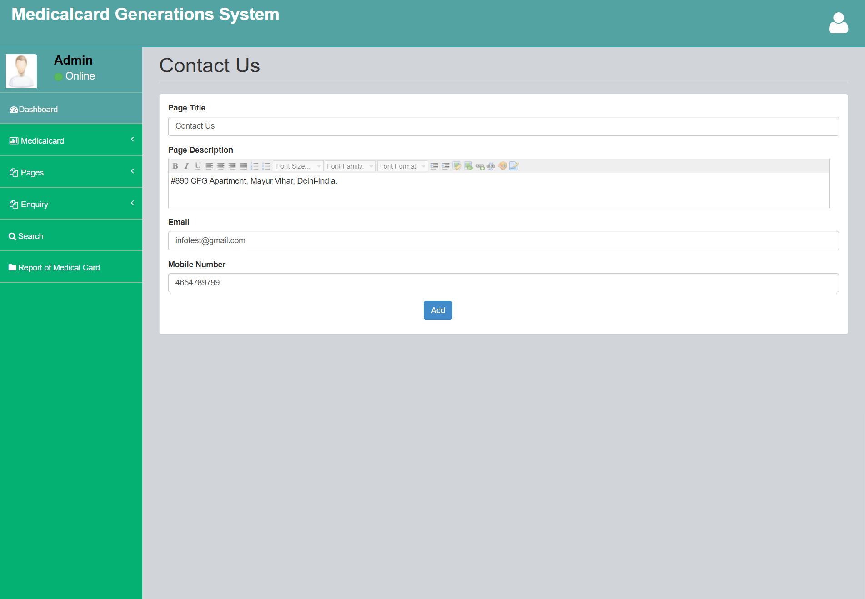

**Manage Enquiries**

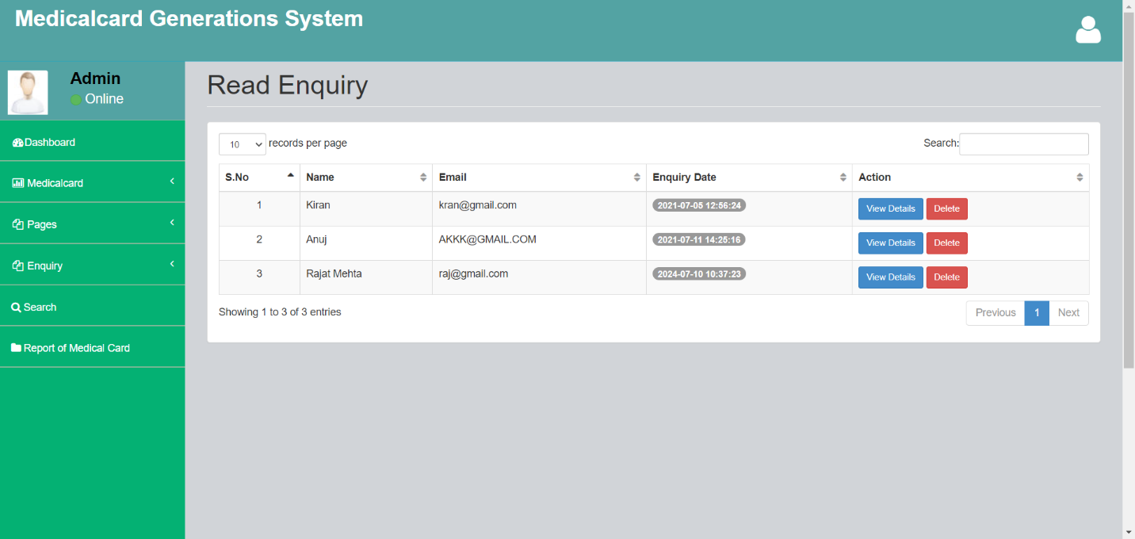

**View Enquiry in details**

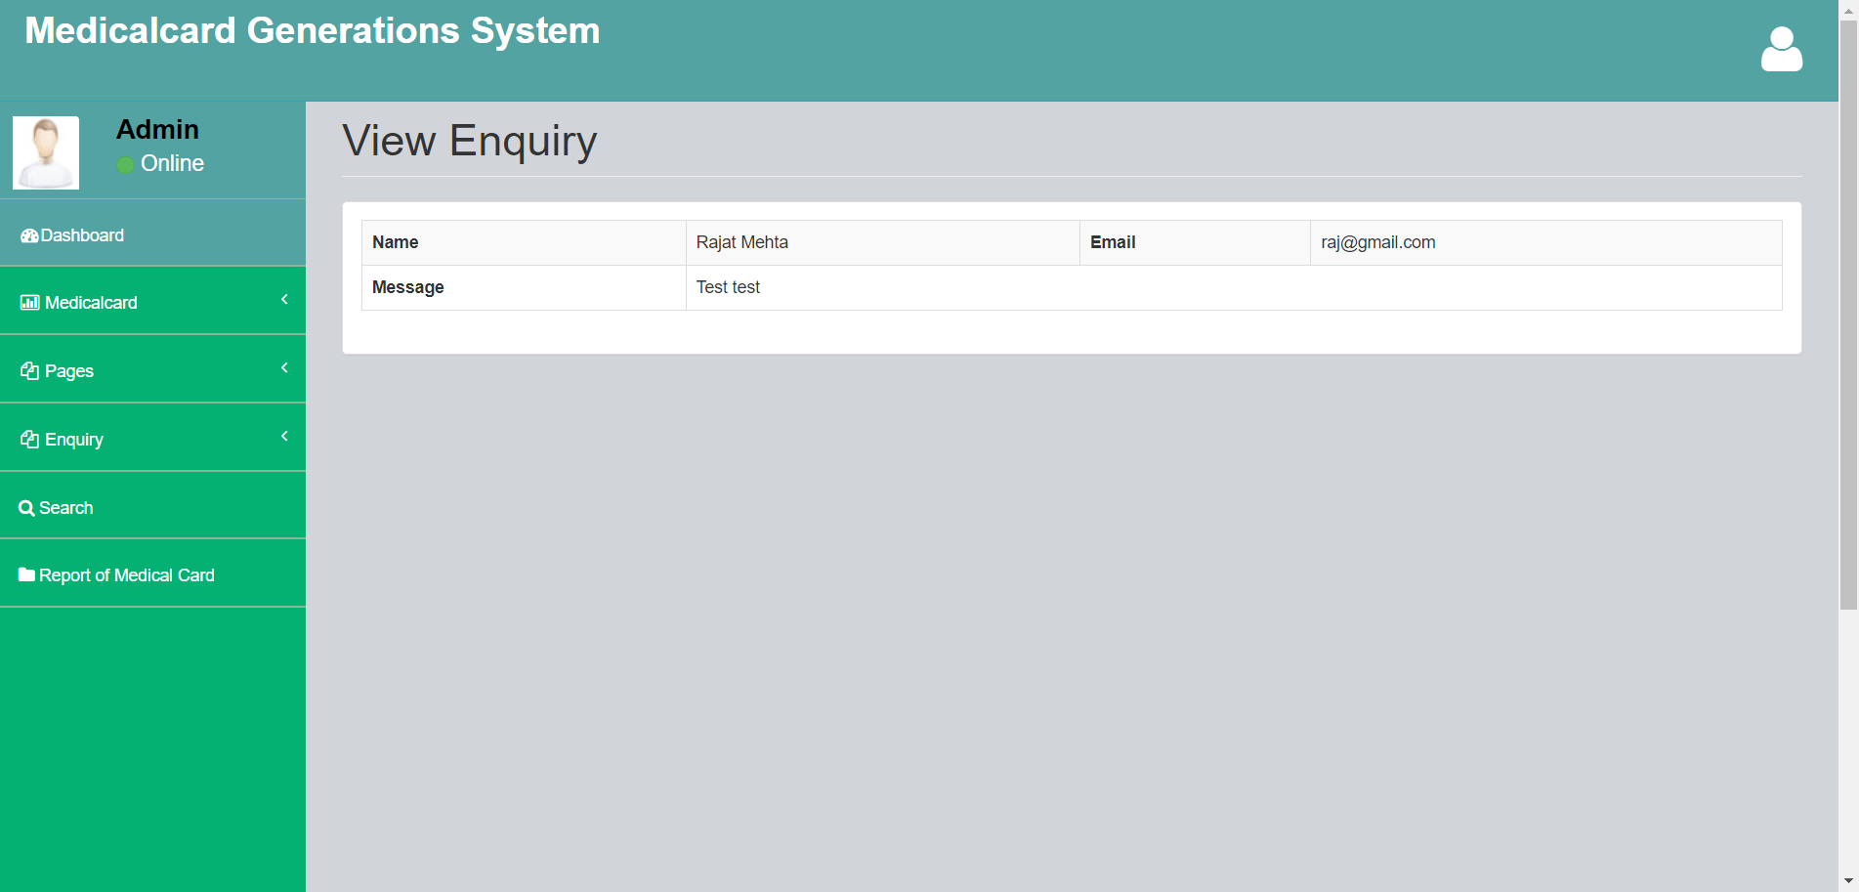

**Search Medical Card**

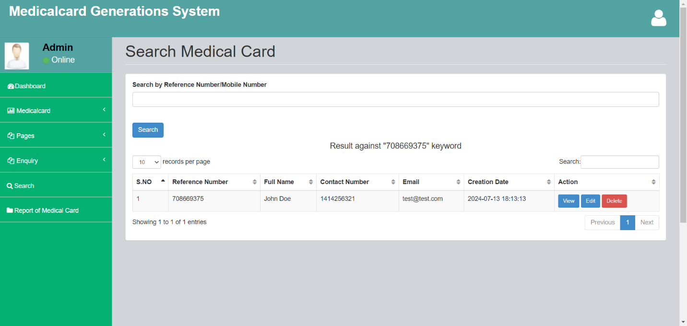

**Between Dates Reports**

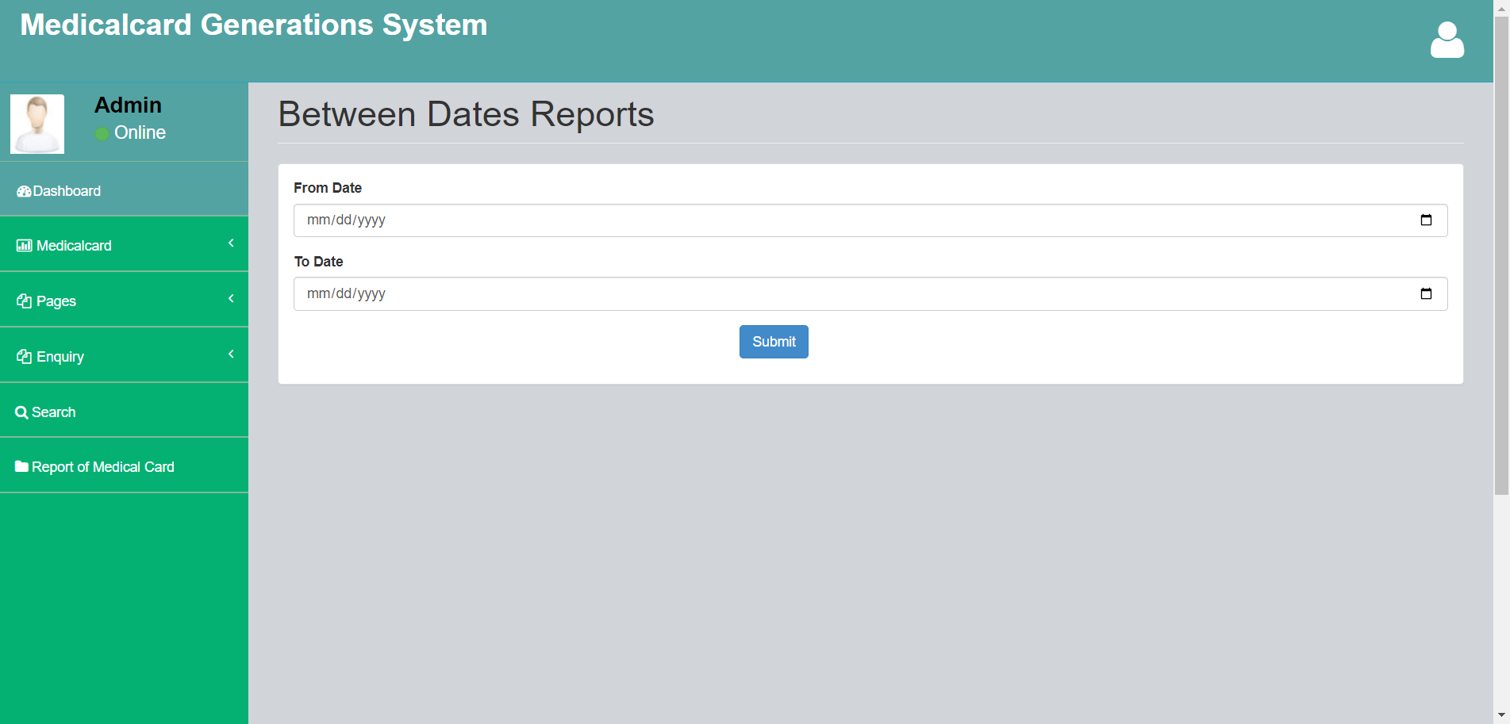

**View between date reports in details**

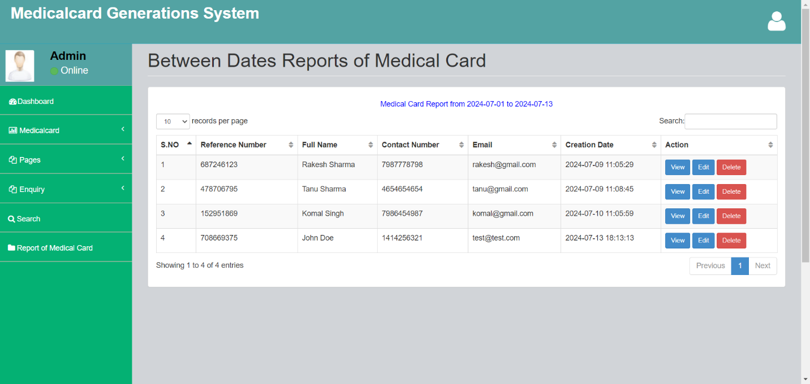

**Conclusion**

This Application provides a computerized and automated version of “Medical Card Generations System” which will benefit the users.

The Application was designed in such a way that future changes can be done easily. The following conclusions can be deduced from the development of the project.

* Automation of the entire system improves the productivity.
* It provides a friendly graphical user interface which proves to be better when compared to the existing system.
* It gives appropriate access to the authorized users depending on their permissions.
* It effectively overcomes the delay in communications.
* Updating of information becomes so easier.
* System security, data security and reliability are the striking features.
* The System has adequate scope for modification in future if it is necessary.

**References**

**For PHP**

* <https://www.w3schools.com/php/default.asp>
* <https://www.sitepoint.com/php/>
* <https://www.php.net/>

**For MySQL**

* <https://www.mysql.com/>
* [http://www.mysqltutorial.org](http://www.mysqltutorial.org/)

**For XAMPP**

* <https://www.apachefriends.org/download.html>